**Sprint Plan 2**

**Task Listing:**

* As a player, I need to see a main menu so that I can start the game. --- (8)
  + Making main menu (6 hours)
  + Make start button (2 hours)
* As a player, I need to see the character and obstacles so that I can play the game. --- (6)
  + Making a character design (4 hours)
  + Making obstacle design (4 hours)
* As a player, I want to move the character so that I can collect fuel tanks (obstacles). --- (8)
  + Making scripts to move character (7 hours)
* As a tester, I want to see a moving background so that it looks like the player is moving. --- (7)
* Make the background move (7 hours)

**Team Roles**:

* Nick Zhang (Product Owner)
* Andres Segundo (Developer)
* Ellie Lin (Developer)
* David Munoz (Developer)
* Brian De Guzman (Scrum Master)

**Initial Task Assignments:**

* Nick Zhang – help create the character
* Andres Segundo – create background object
* Ellie Lin – create Main Menu
* David Munoz – create obstacles objects
* Brian De Guzman – create character design

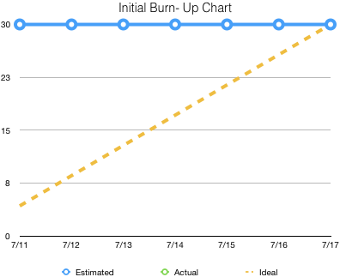

**Initial Scrum Board**



**Schedule of Meeting Times:**

Tuesday (7/11) at 6:40pm at BE 316, Wednesday (7/12) after class at BE lobby, and Friday (7/14) at 5:30pm at BE 316.